Student Performance Analysis and Prediction Using Machine Learning

1. Introduction
Education plays an important role in shaping a student’s future. Understanding the factors that affect student academic performance can help teachers, institutions, and students improve learning outcomes. With the growth of data analytics and machine learning, it has become possible to analyze student data and predict performance accurately.
The aim of this project is to analyze a student performance dataset and predict the final grades of students using machine learning techniques. This project helps in identifying key factors that influence student performance and provides insights that can be used to enhance educational planning and decision-making.

2. Problem Statement
Many students perform differently in academics due to various factors such as study time, attendance, previous grades, and family background. Traditional evaluation methods do not always consider these factors together.
Problem Definition:
To analyze student performance data and predict the final grade of students based on various academic and personal attributes.

3. Objective of the Project
The main objectives of this project are:
- To understand the student performance dataset
- To clean and preprocess the data
- To perform exploratory data analysis (EDA)
- To identify important factors affecting student performance
- To build a machine learning model to predict final grades
- To evaluate the performance of the prediction model

4. Dataset Description
The dataset used in this project is the Student Performance Dataset. It contains information related to students’ academic, demographic, and behavioral characteristics.

Key Attributes:
- Gender – Male or Female
- Age – Age of the student
- Study Time – Weekly study hours
- Failures – Number of past class failures
- Absences – Number of school absences
- G1 – First period grade
- G2 – Second period grade
- G3 – Final grade (Target Variable)
The dataset is suitable for both data analysis and prediction tasks.

5. Tools and Technologies Used
- Programming Language: Python
- Environment: Google Colab
- Libraries Used:
  - Pandas
  - NumPy
  - Matplotlib
  - Seaborn
  - Scikit-learn

6. Data Preprocessing and Cleaning
Before performing analysis, the dataset was cleaned to ensure accuracy.

Steps Performed:
- Checked for missing values and filled them using mean values
- Removed duplicate records
- Converted categorical variables into numerical form using label encoding
- Verified data types of all columns
After preprocessing, the dataset became clean and ready for analysis.
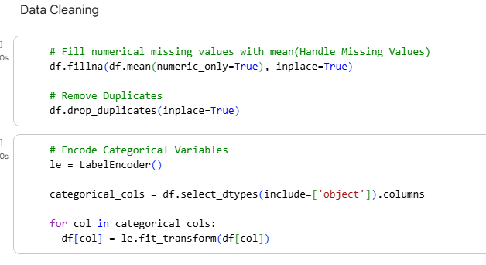

7. Exploratory Data Analysis (EDA)
Exploratory Data Analysis was performed to understand patterns and relationships in the data.

Analysis Performed:
- Distribution of final grades (G3)
- Relationship between study time and final grades
- Effect of attendance on student performance
- Correlation between different variables using a heatmap
Graphs such as histograms, scatter plots, and correlation heatmaps were used for visualization.
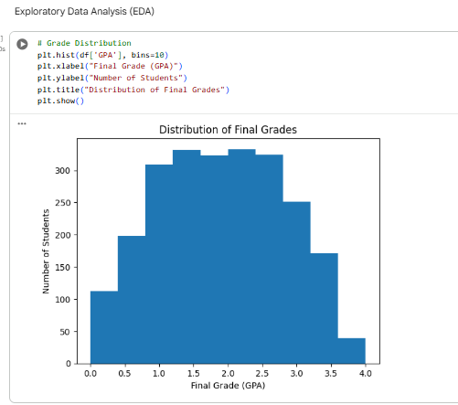
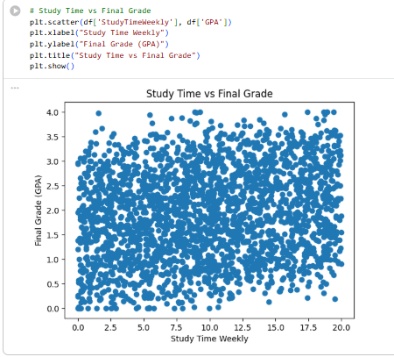
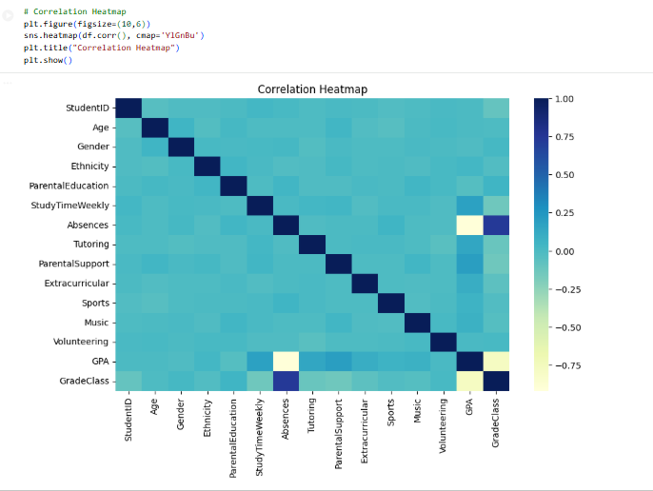

8. Feature Selection
For prediction:
- Input Features (X): All attributes except final grade (G3)
- Target Variable (y): Final grade (G3)
Feature selection helps in improving model performance and accuracy.

9. Model Building
A Linear Regression model was used to predict the final grade of students.

Steps:
- Split the dataset into training and testing sets
- Trained the Linear Regression model using training data
- Generated predictions using test data
Linear Regression was chosen because it is simple, interpretable, and effective for continuous value prediction.
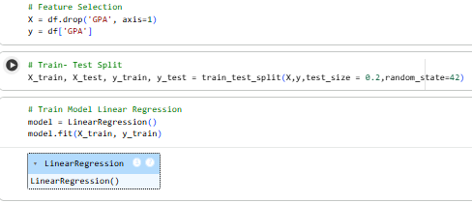

10. Model Evaluation
The performance of the model was evaluated using the following metrics:
- Mean Absolute Error (MAE)
- Mean Squared Error (MSE)
- Root Mean Squared Error (RMSE)
- R-Squared Score (R²)
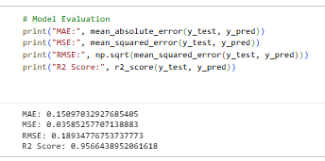
These metrics help in understanding how accurately the model predicts student grades.
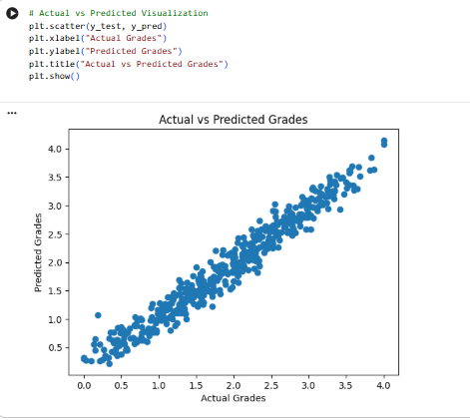

11. Results and Discussion
The model was able to predict student final grades with reasonable accuracy. The analysis showed that:
- Previous grades (G1 and G2) strongly influence final grades
- Study time has a positive impact on performance
- Higher absences generally lead to lower grades
The results confirm that academic and behavioral factors play an important role in student performance.

12. Conclusion
This project successfully analyzed student performance data and predicted final grades using machine learning. The insights obtained from this analysis can help educators identify weak students early and provide additional support. The model can be further improved by using advanced algorithms such as Decision Trees or Random Forests.

13. Future Scope
- Use advanced machine learning models for better accuracy
- Include more student behavioral data
- Deploy the model as a web application for real-time prediction

14. References
- Student Performance Dataset
- Scikit-learn Documentation
- Python Official Documentation

